

From Migrating Cell to Shape Space

# Terminologies for the Tutorial

To make the tutorial easy to read, a couple of terms are introduced:

* Movie folder: the folder containing your microscopy data
* Analysis folder: your generated folder containing the complete set of analysis from this tutorial. For this tutorial it is important to save all outputs in this folder unless stated otherwise.
* Run a “specificMatlabFile.m”: this means, the path is added to your path, and a click on the “Run” button in the toolbar executes the program. Should these instructions feel unfamiliar, read the next Section “New to Matlab”
* Matlab: Please install MatlabR2013b. The program is only tested with this edition on Mac OS X. Matlab offers earlier versions in its Download centre, which you have access to.
* All figures produced in the tutorial are automatically saved in the folder Analysis🡪Figures

# New to Matlab

If you have never used Matlab before, you should to install the program and obtain a license first. Most universities offer free licenses for staff and students.

A comprehensive guide can be found at Mathworks

<http://uk.mathworks.com/help/install/installation-and-licensing-fundamentals.html>

For the tutorial, we recommend the version **MatlabR2013b**, to guarantee all functions are working properly. To download perform please the following steps:

* Login to [www.mathworks.com](http://www.mathworks.com)
* Click My Account
* Click "Download Now" under Account Services, below the wording "MathWorks Account
* Click Download on the next page (under Licensed Products and Updates)
* On the following screen, there is a selection of newest release. To the right of the most recent version link, there is the link "Choose another release"
* After clicking select MatlabR2013b and proceed with download
* NOTE: This facility is not available for Student Version or trials since they are version specific.

To run the tutorial, you need the folder ShapeSpaceExplorer containing all files. Within the Matlab program go to the folder “ShapeSpaceExplorer” (see figure below).



Then, right click on ShapeSpaceExplorer folder, and select “Add to Path” 🡪 Selected Folders and Subfolders (see below)



This adds the ShapeSpaceExplorer to the Matlab paths, which means, the programs are easy to execute. The ShapeSpaceExplorer folder should appear as active (see figure below)



To run a program, open ShapeSpaceExplorer 🡪 1-ImageSegmentationFull and select the File “Run_CellSegmentation.m” with a double click (see below). Then click on the “Run” button in the Toolbar. The first line in the command window should then contain the line   
>> Run_ Run_CellSegmentation

Once a program has finished properly, the program lines writes at the end:

>>

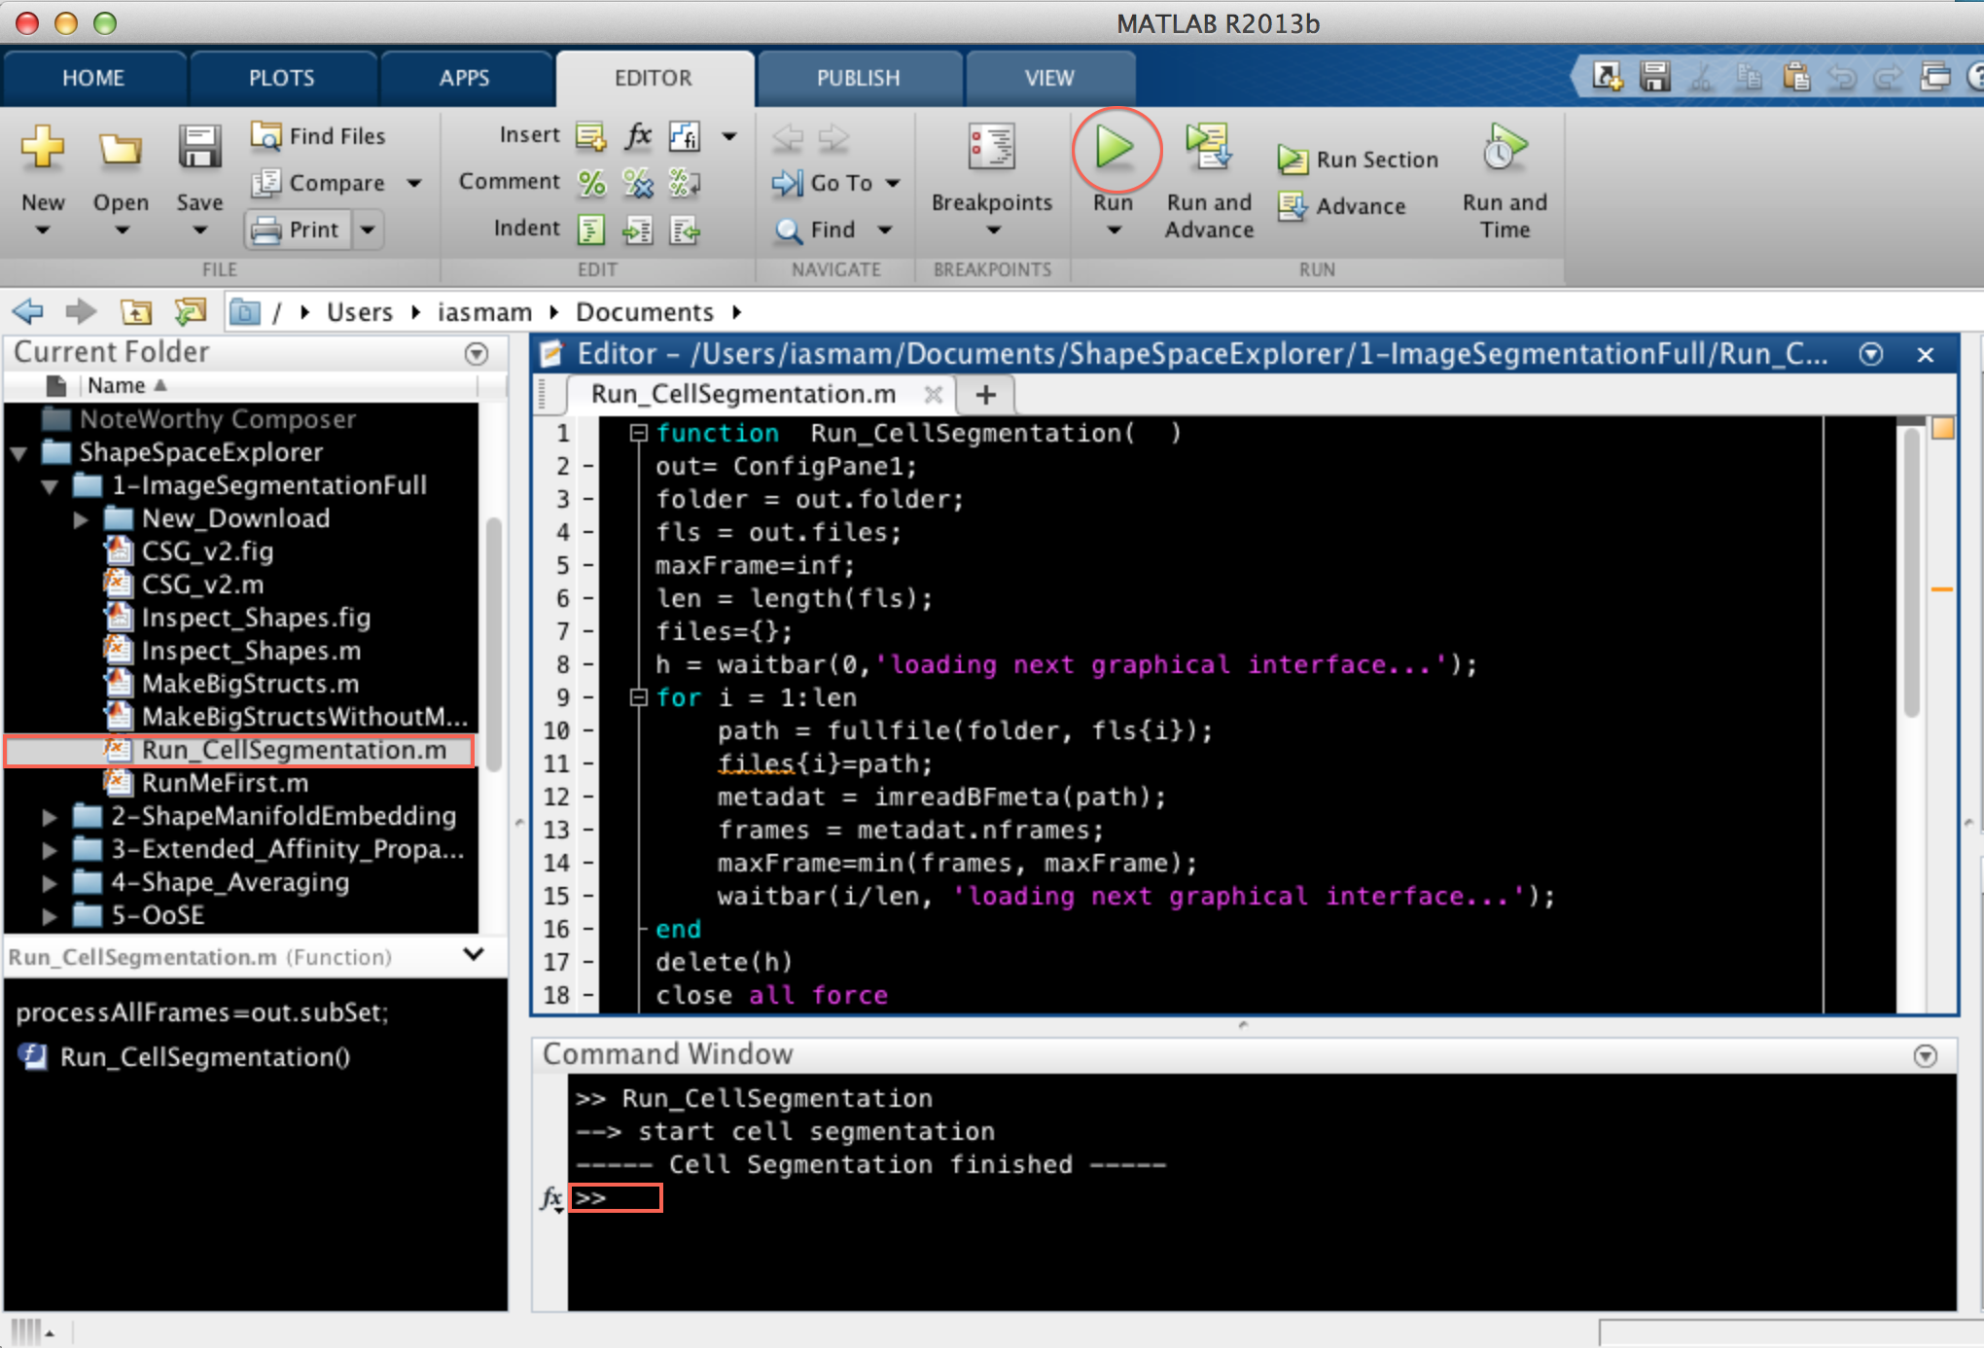

1st Step : Cell Segmentation

Cell Segmentation starts with the microscopy data in your Movie folder saved in “.DV” file format.

To run cell segmentation, go to ShapeSpaceExplorer 🡪1-ImageSegmentationFull, open the file “Run_CellSegmentation.m” and click on “Run” which should show the interface below:

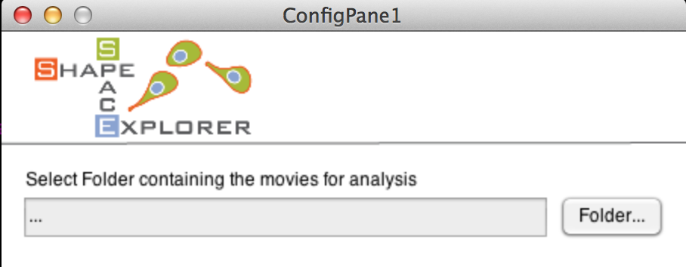

Select your Movie folder containing your microscopy data, which should show all files in a selectable list (see below).

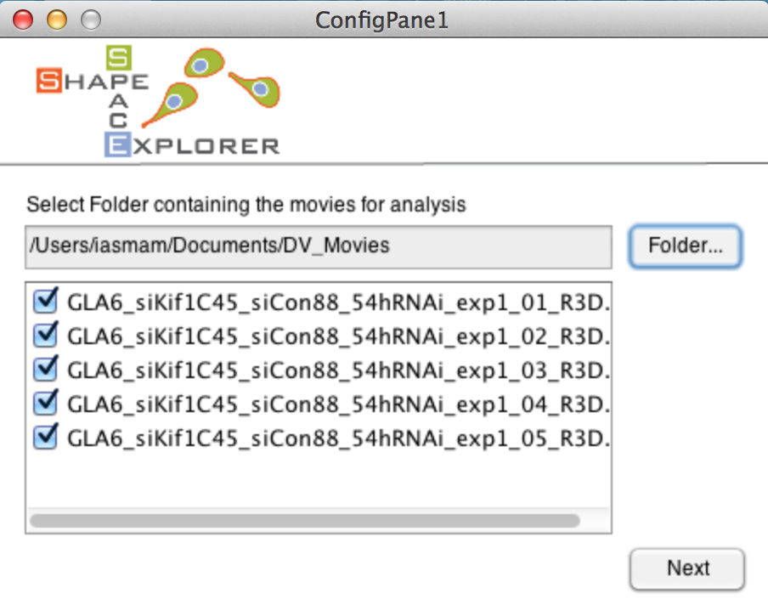

Select all movies that should be analysed. Note that at least one file must be selected to continue which should lead to the next interface (see next page). Note, the loading of the interface is slow, because it calculates the number of frames of your shortest movie from all movies files.

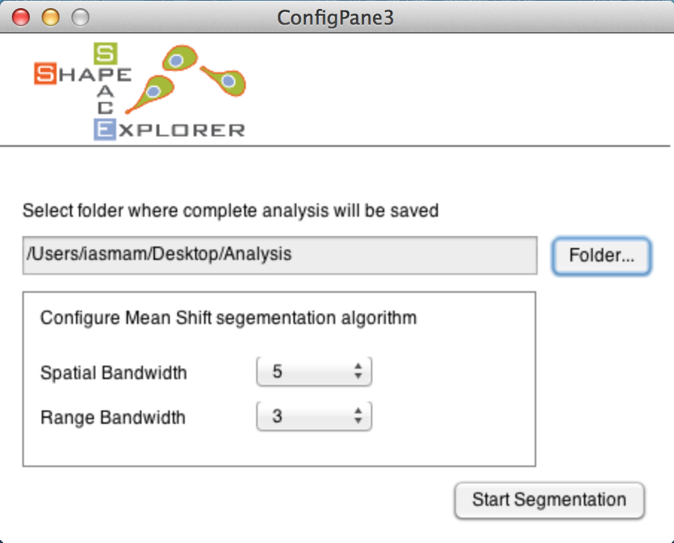

The interface offers two choices: first to analyse all movies from start to end (default choice) and second to select a substack of your frames, which might be helpful if your data went out of focus. Should you select a substack from frame A to frame B, this selection is automatically applied to all movies in your analysis.

The final interface asks you for the Analysis folder to save the output of the cell segmentation (see below). Clicking on Start Pre-processing starts automatic cell segmentation. This is a time intensive task and can take several hours to a few days depending on your data size.

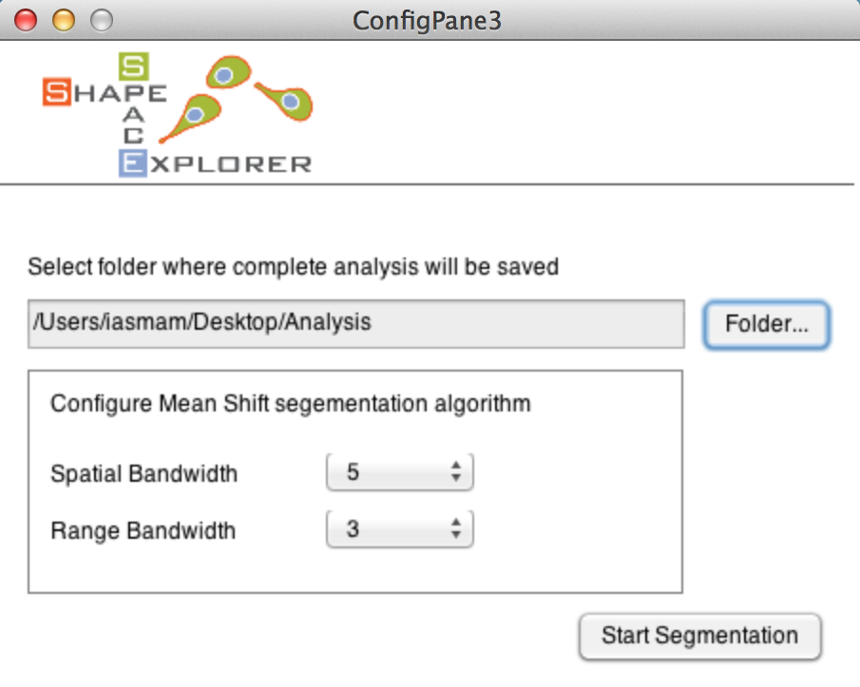

Two waitbars indicate the progress of cell segmentation. At the end, the commando line prints a note when the program finishes successfully (see example below).







After cell segmentation, the Analysis folder should have the following new files:

* ImageStackXXX.mat for each selected movie
* ImageStackXXXCurveData.mat for each selected movie
* FileMapping.csv: contains the mapping between the new movie names and the original movie names from the Movie folder. Excel can import CSV files.

Note: for Matlab 2012b, the mapping is written to FileMapping.mat, as csv table writing is not supported.

Caveat for Cell Segmentation

The cell segmentation in ShapeSpaceExplorer uses an implementation of the Mean Shift Algorithm with the EDISON wrapper (**E**dge **D**etection and **I**mage **S**egmentati**ON**), The reference and details of the algorithm can be found in: D. Comanicu, P. Meer: "Mean shift: A robust approach toward feature space analysis." IEEE Trans. Pattern Anal. Machine Intell., 24, 603-619, May 2002.

NOTE: Should the segmentation produce strange outputs, then there are two parameters to adjust the algorithm: Spatial Bandwidth and Range Bandwidth.

Generally speaking, the range bandwidth influences how much noise the cell segmentation picks up. Should there be too many smalls blobs recognized as cells, this parameter should be increased.

The spatial bandwidth, influences on how large the radius of a detected shape can be as smallest possible radius. Depending on your imaging conditions and average size of your cell, the interface permits to fine tune the cell segmentation step. Though, the proposed default values worked for a white range of cases.

An excellent detailed explanation on how the parameter influence cell segmentation can be found on Wikipedia: <http://en.wikipedia.org/wiki/Mean_shift>.

Manual correction of Cell Segmentation

To inspect the cell segmentation results, run the file 1-ImageSegmentationFull🡪 Inspect_Shapes.m in the ShapeSpaceExplorer folder producing the interface below:

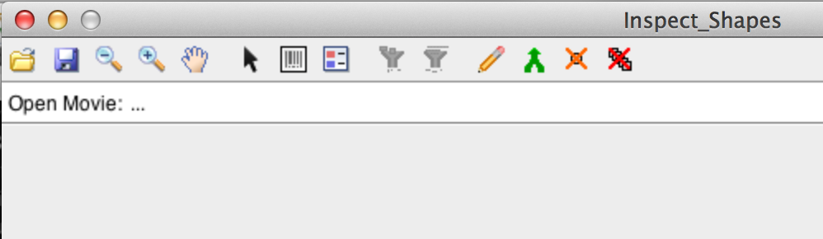

Click on the folder icon in the toolbar and select one of the files with the name format ImageStackXXX.mat, for example ImageStack001.mat. The program highlights the contours of the detected cells. The toolbar offers zoom in, zoom out and pan operations. The 8th icon from the left is the legend icons and permits you to see the id assigned to detected shapes.



There are a variety of operations that permit to correct the automatic cell segmentation manually. Each of the operations is explained in the following sections.

Delete a single Shape



Selecting the Cursor and clicking on a shape removes the shape from the detected cells, indicated by a grey outline. To remove a shape from a frame plus all future frame you need to hold down the key CTRL and click on the shape. To add the shape back to detected shapes, simply click with the Cursor selected inside the shape, which should re-colour the shape in a bright colour.

Filter out shapes with small area size



The filter is applied to the complete stack. All active shapes smaller than your minimum size will become deselected.

Filter for sort live span



Merge



Manual Drawing



You have the full functionality of the Matlab ROI tool,

Full Description here: <http://uk.mathworks.com/help/images/ref/roipoly.html>

* Delete: Backspace
* Adding a new vertex: Key A
* Delete vertex: right click, and select delete
* Closing Polygon: Move to an existing point and click on it.

Continues tracks

For the analysis presented in this tutorial, continuous tracks are cell tracks that stretch from a start frame to an end frame, without any interruption. The cell with id one, appearing from frame one to five [1,2,3,4,5] would be an example.

However, if the track would have a missing frame, say at frame three, so that the sequence is [1, 2, 4, 5], then when the program saves your modification, it will assign a new id to the second part of the track.

When you save 3 new files should be produced:

* CellAray001.mat
* CellFrameData001.mat
* ManCorrtdCurves001.mat

# Step 1.5: After manual correction

The tutorial expects you to open each stack in InspectShape.m program and save it from there. For each stack ImageStackXXX.mat, the program creates two files, namely CellArayXXX.mat, and CellFrameDataXXX.mat.  
The analysis integrates only stacks that have those two files generated. To proceed run   
1-ImageSegmentationFull🡪MakeBigStructs.m

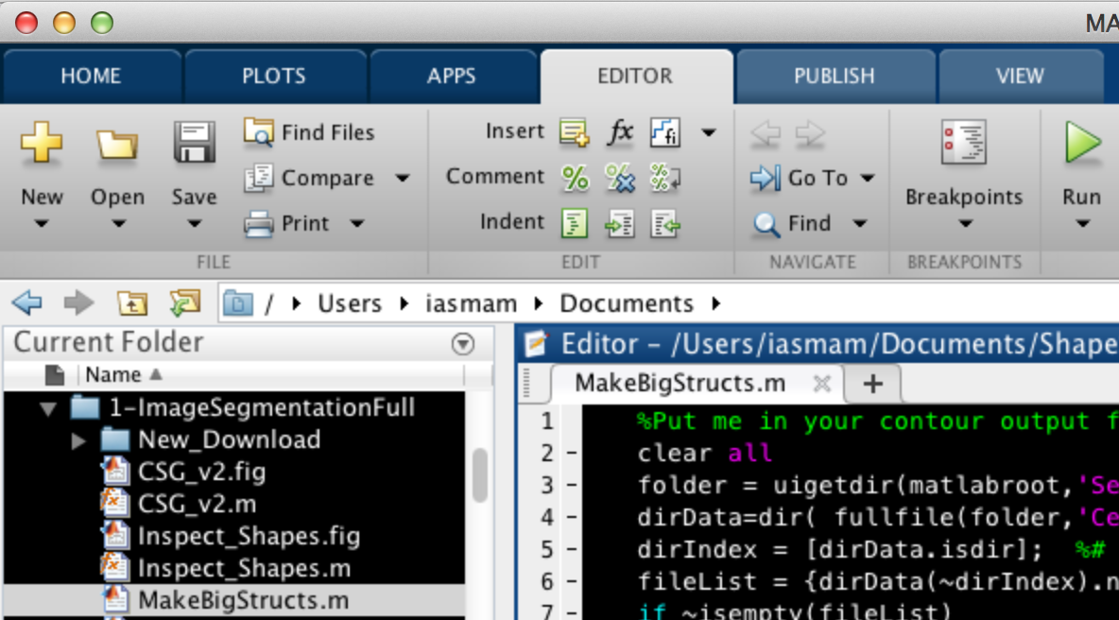

After selecting the Analysis folder, the program generates two files:

* Bigcellarrayandindex.mat
* BigCellDataStruct.mat

Note: you can construct the “Bigcellarrayandindex.m” and “BigCellDataStruct.mat” without manual correction; to do so, run   
1-ImageSegmentationFull🡪MakeBigStructsWithoutManual.m

Note: the program MakeBigStructsWithoutManual.m does not include any existing manual corrections.

Step 2nd : Shape Manifold Embedding

Now, run ImageSegmentationFull🡪 RunShapeManifoldEmbedding.m, which asks for the Analysis folder as input.

Once correctly completed, the following dialog box appears and should have created the file CellShapeData.mat in the Analysis folder



Note: this process is slow: for a set of ca. 37818 shapes, the calculations require about 31 hours, approximately 1.5 to 2 days.

# Step 3a: Extended Affinity Propagation

This step determines similarities between shapes.

In this step, similarities between shapes are determined. For pre-processing run

ShapeSpaceExplorer🡪3-Extended_Affinity_Propagation 🡪 Run_Affinity_Propagation.m

Note: this step needs first to load CellShapeData.mat; when this file is large, say about 20 GB, loading the file may take half an hour where the computer gives no feedback.

Once loaded, the program prints progress on the console.



After successful completion, the following nine files should have been generated in the Analysis folder:

* avail_list.mat
* APclusterOutput.mat
* double_sim_matrix.mat
* linkagemat.mat
* pref.mat
* resp_mat.mat
* single_sim_matrix.mat
* unconv.mat
* wish_list.mat

Inspecting automatic classification of shapes

To inspect the automatic classification, run  
3-Extended_Affinity_Propagation 🡪 Inspect_ShapeAffinity.m , select the Analysis folder, and then the program produces two figures (see below)

 

The left figure shows the average shape for each cluster, while the right figure shows ten examples from each cluster.

Dendogram of Shapes

Often, the program produces to many clusters and it is desirable to constraint the number of clusters. To make an informed choice, the cluster dendogram should be consulted.

Run 3-Extended_Affinity_Propagation 🡪 Run_Dendogram_of_Shapes.m , select Analysis folder, and then the program produces the cluster dendogram (see below).



Constrained Clustering

For a constrained clustering run  
3-Extended_Affinity_Propagation 🡪 Run_constrained_Clustering.m,

select the Analysis folder and configure the number of clusters (see figure below)

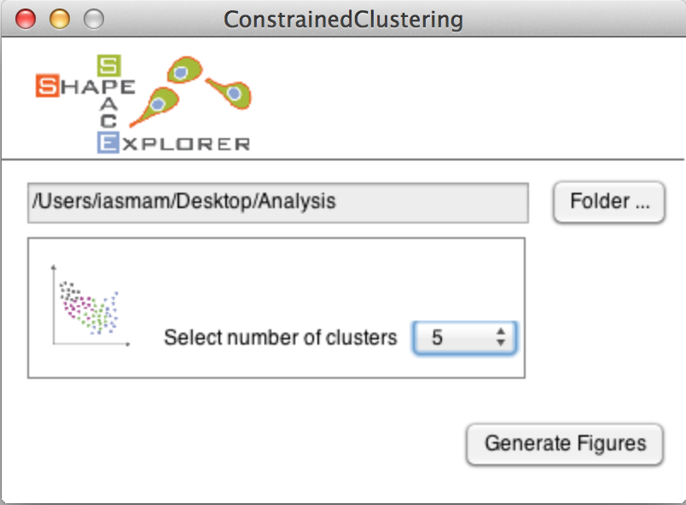

Note: The number you enter for constraint clusters must be smaller than the maximum clusters otherwise the program terminates without results.

 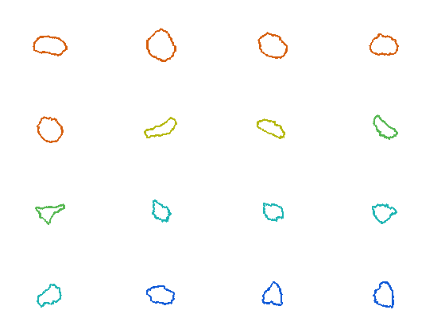

Left figure shows the shape space coloured in the five cluster colours. Each dot in the figure corresponds to a cell shape. The x and y axis show are the two most striking features for the set of cell shapes, the first two Eigenvalues. The right figure shows exemplars of shapes for each of the five clusters.

# Step 3b: Group Analysis

A classical example for group analysis might be that your data is divided into three samples: control, treatment1 and treatement2. This group analysis permits to see the clusters of each group in shape space, the relative number in the different clusters, persistency and average speed of each group.

Run 3-Extended_Affinity_Propagation 🡪 Run_GroupAnalysis.m

select the Analysis folder and the ideal number of clusters determined in the Step 3a from the dendogram.

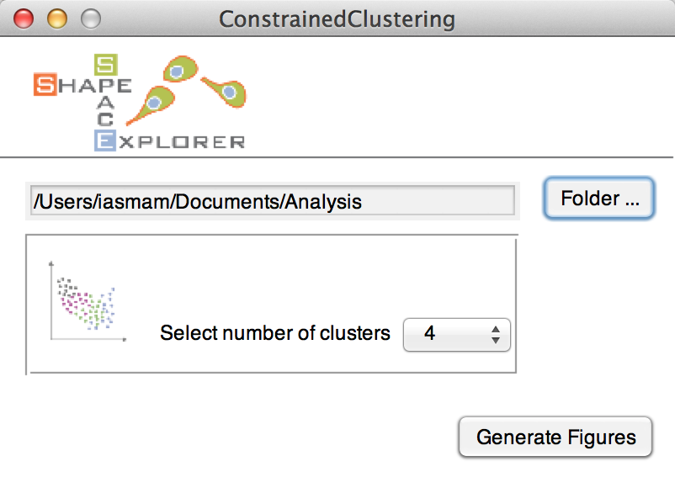

Define the Groups by entering a group name and the stack number. A mapping between stack number and original file is in ‘FileMapping.csv’, generated in the cell segmentation step.   
Note: Avoid white space for group names as they are used later directly in figure paths, and may cause issues on some operating systems.

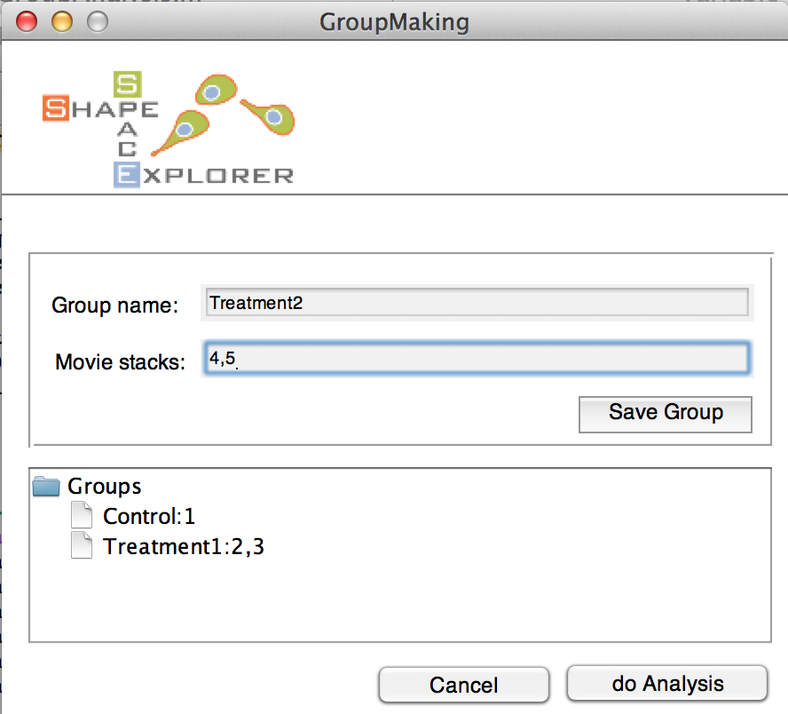

Note: stack numbers from one to five can be entered in several ways, such as

* 1-5
* 1,2,3,4,5

Also, to delete a group, hold CTRL and click on the group, which produces a context menu with a delete option.

For each group analysis, the program creates a new folder with time stamp, for example “GroupAnalysis_2015-04-15_095836”. The folder contains the following results for each group:

 

Left images shows shape space in gray, with group elements in cluster colour, while right image shows group elemetns as full circles and non-group elements as empty circles in shape space.

 

Left figure shows the relative amount of shapes in the clusters, while right figure shows Eucledian ratio persistency of the group, a ratio between accumulated distance and shortest possible distance over different time lags.

 

Left figure shows relative count of all groups with respect to cluster 1 (red), while right figure shows bar plots with absolute counts. For all bar plots, the numbers are written in text format in the Group Analysis folder.

Finally, the averages speed in shape space is written in “AvgSpeedPerGroup.csv”. The unit of the speed is [unit in shape space/ time point difference]. If your movies took a frame every 5 minutes, than the respective unit would be

[1 unit in shape space/ 5 minutes].

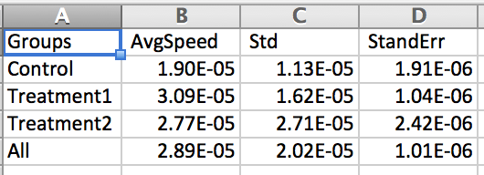

# 4th Step: Shape Slicer

To run the shape slicer, go to folder 4-Shape_Averaging and run “Run_SpaceSlicer.m”, which opens a configuration window (see below).

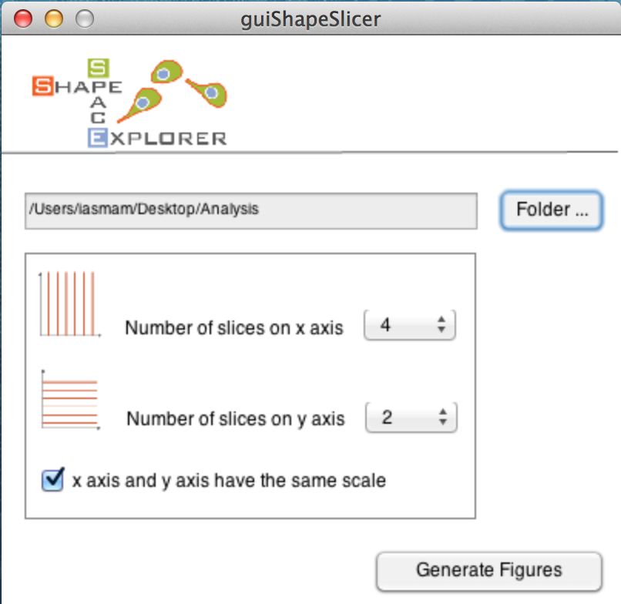

Select the Analysis folder and the number of slices the x and y axis should be divided into. The program produces the figure below.

Macintosh HD:Users:iasmam:Desktop:combined.eps

Each dot corresponds to a shape in shape space. Here, the x-axis is sliced into 4 sections. For each section, the program produces an average shape (see blue shapes). Similarly, the y-axis is sliced into two sections, and the respective average shape is plotted in green.

To make the results graphically more appealing, the program writes the single items, such as contents and average shapes of x- and y-axis into single figures, permitting to edit the elements in graphic programs able to deal with EPS file format.

# Step 4 b: Space Slicer with Group Analysis

# Macintosh HD:Users:iasmam:Desktop:Screen Shot 2015-06-04 at 20.14.14.png

To see the group distribution in space slicer, tick the last choice box (load group analysis). Then, the program ask for a group folder (see below)

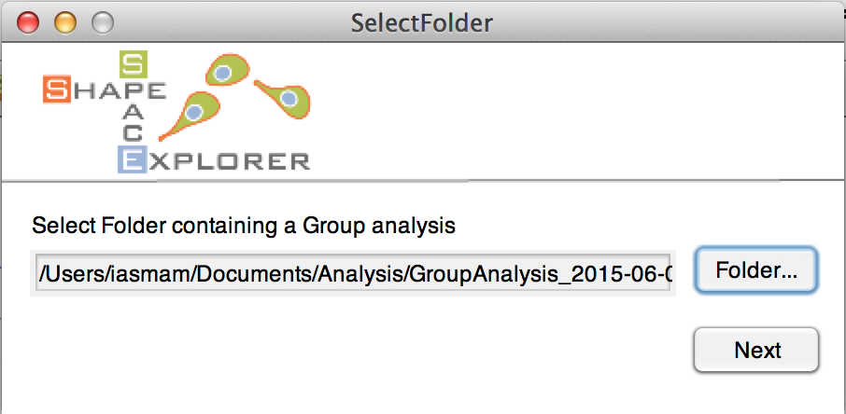

Below is a the shape spaced sliced, with the coloring of the group analysis.



# Step 4 b: Interactive Average Cell Shape

For Interactive Shape Slicer run 4-Shape_Averaging 🡪Run_SpaceSlicer.m, click on the folder icon and select the Analysis folder, which should show the space shape.

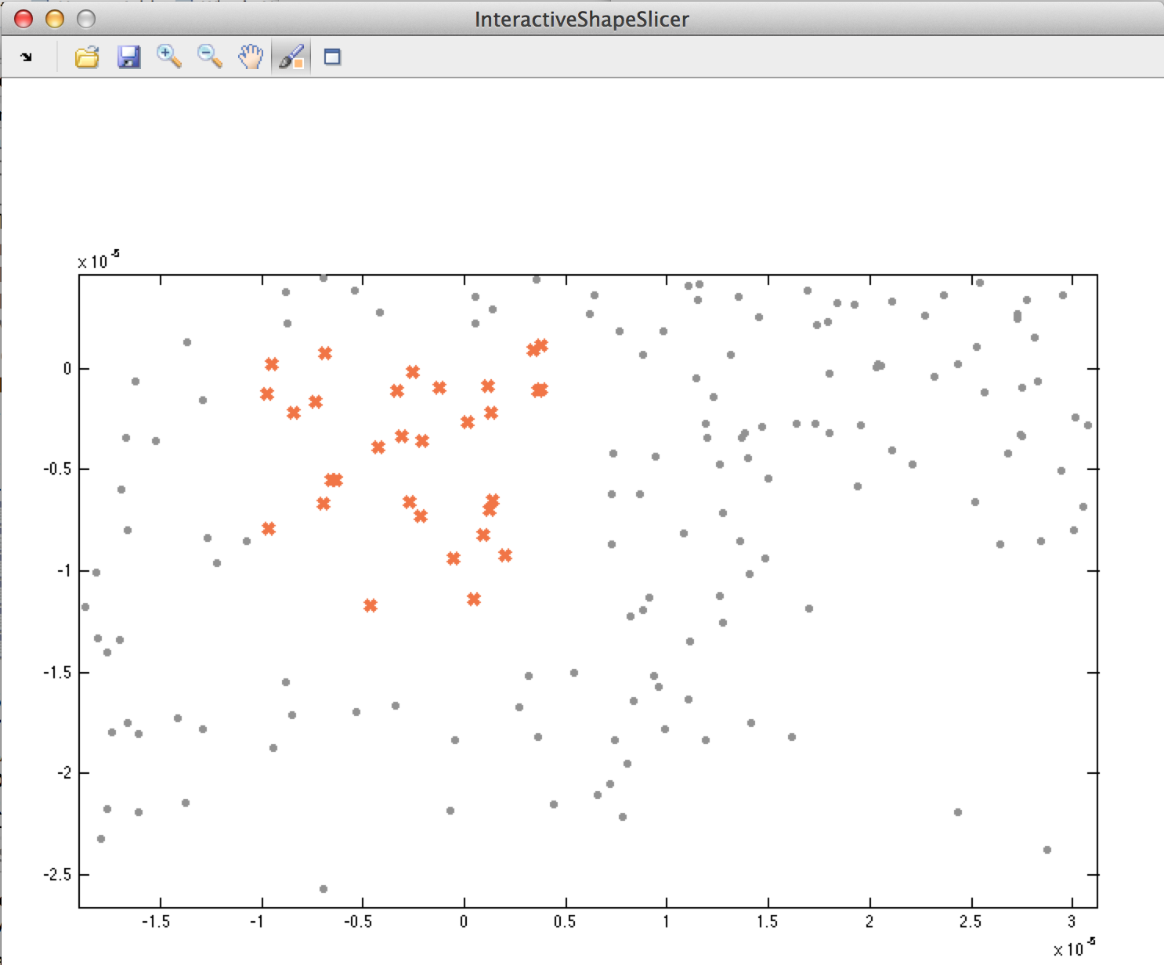

The data brush (sixth icon from left in tool bar) permits you to select a sub group of shapes (dots) in shape space. To produce the average shape space, click on the frame icon (seventh icon from left in tool bar), and the program generates the average shape with its respective coloured shape space.

Click on the save icon in the tool bar to save both figures (average shape and respective shape space).

Note: data brush allows with CTRL + data brush to add single points from MatlabR2013 onwards, but not in Matlab R2012a.



Left selected items in shape space, right figure: average shape of selected shapes.

# 5th Step: Out of sample extension

First step: create a folder called OOSE (possibly inside Analysis folder), then perform the following two preparatory steps:

* Run 1-ImageSegmentationFull 🡪 Run_CellSegmentation.m and select OOSE as your Analysis folder
* Either correct Data manually, using “Inspect Data” for all ImageStacksXXX.mat and run   
  1-ImageSegmentationFull 🡪 Make_Big_Structure.m or continue without inspection running

1-ImageSegmentationFull 🡪 MakeBigStructsWithoutManual.m

Now, run 5_OoSE 🡪run_OoSE_training and configure the next step (see below)

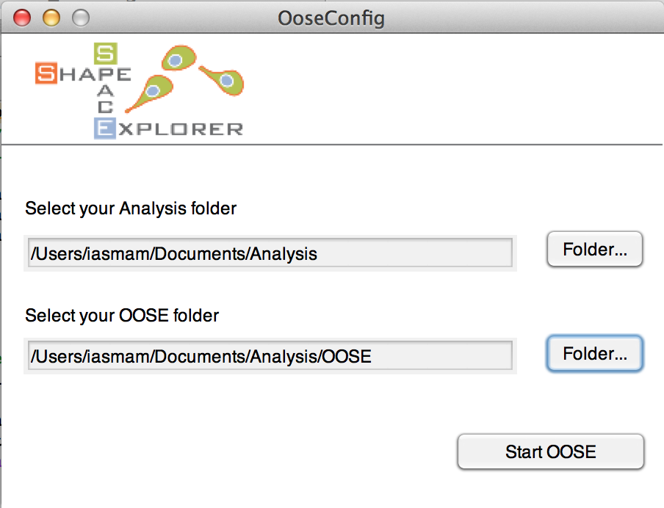

Once completed successfully, the OOSE folder contains the new file:

* LP_trained.mat; its structure has Nx5 matrix, where N is the number of frames analysed.

To generate the distance matrix run 5_OoSE 🡪 generate_OoSe_distMatrix.m

(see image below)



Now, progress bars should appear, going through 3 steps.   
Embedding is a slow progress, and might seem frozen. For 88 movie stacks embedded into 114 control stacks, it takes about 11 hours.



After correctly finishing, there are two new files in the OOSE folder:

* OoSE_embedding.mat
* Dist_mat.mat

To compare the OOSE sample within the shape parameters and cluster parameters of say the control sample, run

5_OoSE 🡪 compareBargraphs.m

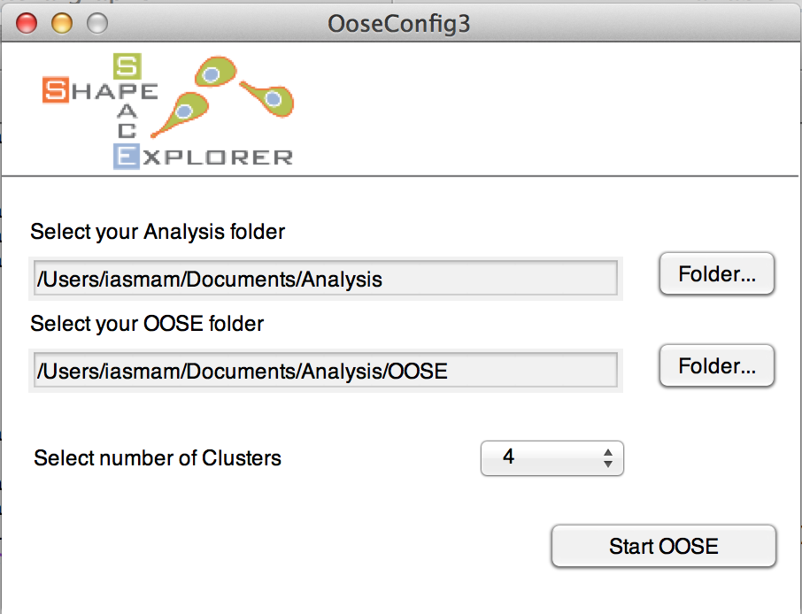

For clusters, select the best numbers from the reference (Analysis) sample. The new subset will be plotted in shape space using the two most distinctive features for x- and y-axis from the larger sample in Analysis. Also, for the clustering, the sample in Analysis is used as ‘reference’ clusters, and this permits to see how this sample extension compares to a larger sample or a control sample.

  

Left: shows bar graphs for clusters with absolute numbers, middle shows shape space with reference dots in grey and sample extension in colour, right figure plots extension shapes in full circles and reference shapes in empty circles.

Note: All Figures are plotted in OOSE/Figures, with numbers of bar graphs written in CVS files.

# 6th Step: Display Shape Features

To pre-process data for shape features run

6-ShapeFeatures 🡪Run_ShapeFeature_Processing

select the Analysis folder. A progress bar should appear, indicating how long the program takes to complete.



After successful completion, the program should have created the file

* Morphframe.mat

To generate various shape feature plot, run

6-ShapeFeatures 🡪 generateShapeFeature

and select the type of graphs the program should create (the example below selected Area and Circularity):

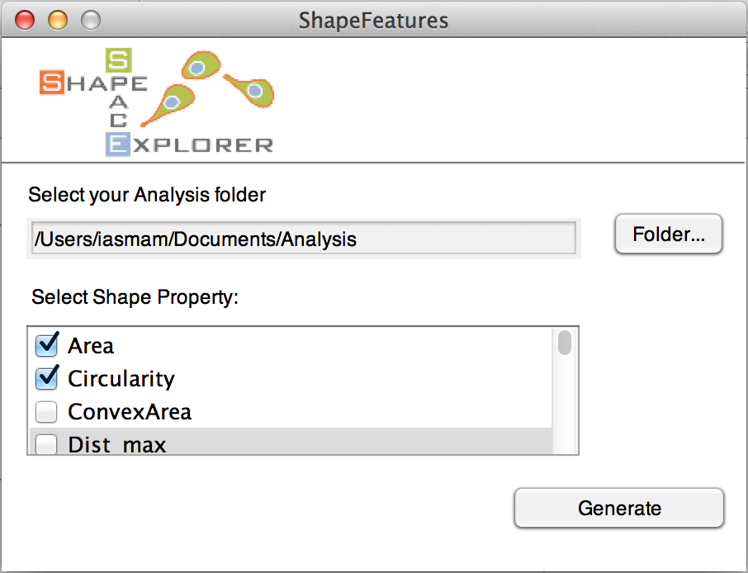

After successful generation, the programs plots all figures in the folder Analysis/Figures/6_ ShapeFeature_<property>.eps

For Circularity, the file name is 6_ ShapeFeature_ Circularity.eps (see below)



## Step 6b: Interactive Shape Explorer

The interactive shape explorer permits to inspect the track of a single cell in shape space over time.

Run 6-ShapeFeatures🡪CellTrackViewer

(see below)

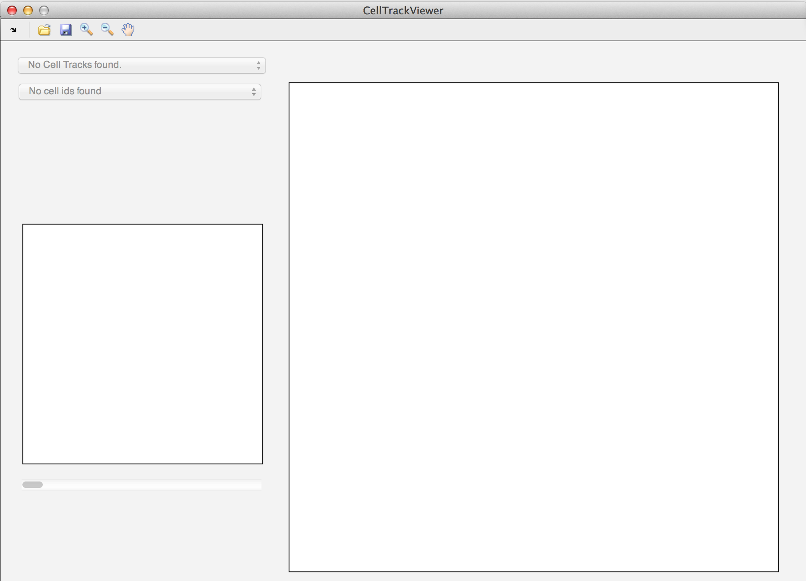

Then, click on the folder and open the Analysis folder. The first drop down menu permits to select the Image Stack of the sample, while the second drop down menu shows all non-empty cell-ids of this image stack.

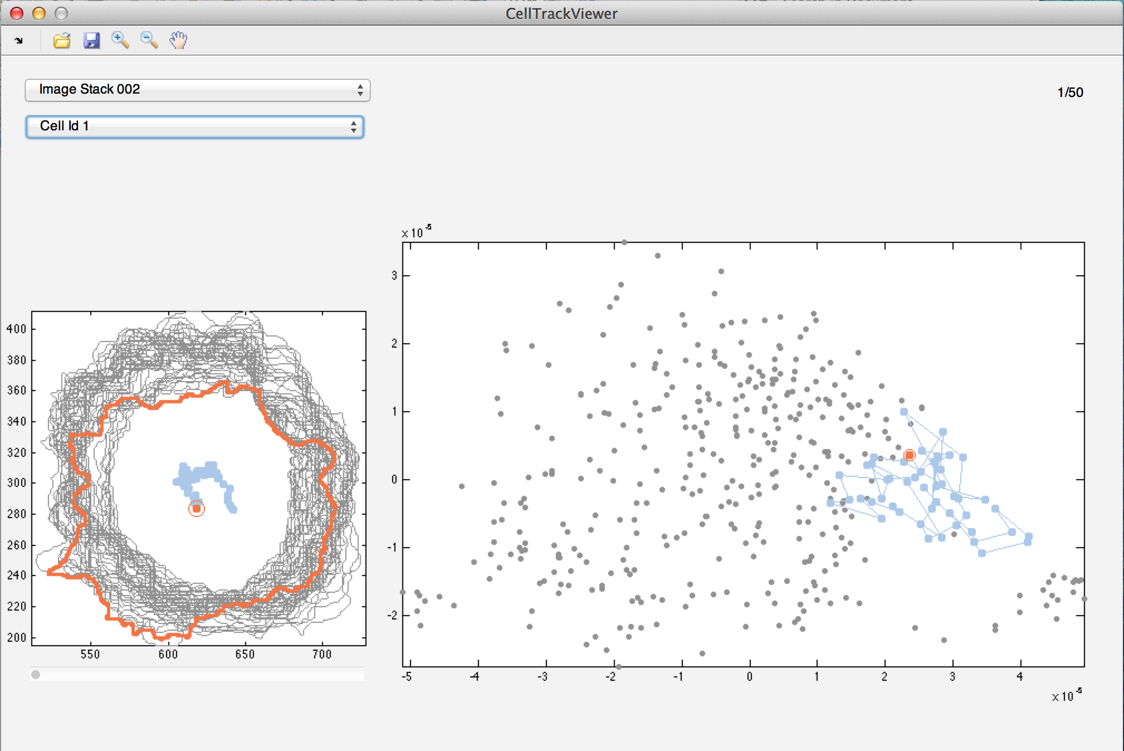

Note: when saving a track of a cell, the program saves a movie for the track in shape space and the shapes in the shape plot individually and combined in tiff format, as well as each frame in EPS format, which permits to edit them easily.

# 7th Step: Shape Space Dynamic

For dynamic data, start with pre-processing and run

7-ShapeSpaceDynamics🡪 Run_DynamicData_Generation.m

and select the Analysis folder.

After successful completion, the program should have generated the file:

* DynamicData.mat

The inside of the DynamicData.mat consists of the following variables:

* struc.track: contains the x,y coordinates for a cell id in shape space, for each frame.
* struc.track: contains the speed for a cell id, for each frame.
* struc.average_speed: a single number, containing the average speed for a cell id.
* Struc.angles: contains the angle of a cell id for each frame.
* Struc.av_displacement_direction: a single number showing the average displacement direction.

Note: InspectData from 1st step, permits only cells with continuous detection to have the same id. Hence, per definition each cell id has equally distant time points, or in other word, no gaps in time points.

### Sliced Shape Space Average Dynamics

This program permits to see the average behaviour of slices in shape space.

Run 7-ShapeSpaceDynamics🡪 Run_Sliced_Dynamics.m

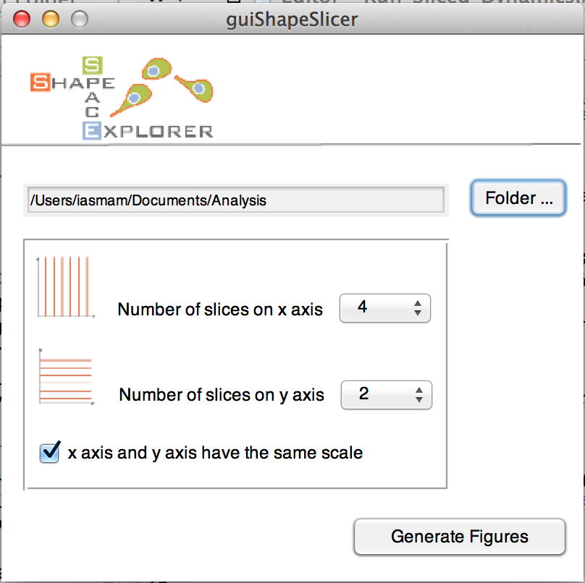

Select the Analysis folder and the number of slices for the x- and y-coordinate in shape space before clicking on “Generate Figures”

The program produces a figure, where for each slice in shape space a rose plot is plotted (see example below).



### Explore Average Behaviour of Clusters

Run 7-ShapeSpaceDynamics🡪 Run_Clustered_Dynamics.m,

Select Analysis folder, and number of ideal clustered (determined in step 3 via the dendogram).

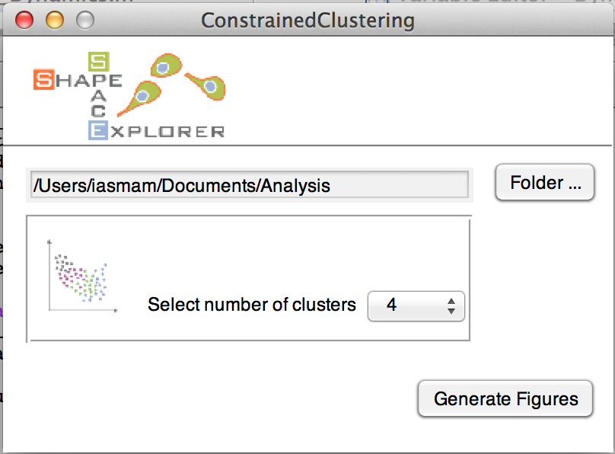

An example graph could look similar to the image below:



And a detailed view of two shapes in a certain class could look like this:

